WhatNext Vision Motors: Shaping the Future of Mobility with Innovation and Excellence

1. PROJECT OVERVIEW
WhatNext Vision Motors: Shaping the Future of Mobility with Innovation and Excellence is a Salesforce-based CRM solution designed to manage and streamline the core operations of a modern automobile business. The application provides a centralized platform for managing vehicle customers, vehicles, dealers, vehicle orders, test drives, service requests, reports, and dashboards.
The system reduces manual effort by using Salesforce automation to manage important business processes. Customers and vehicle information can be maintained in a structured manner, while vehicle orders can be processed according to inventory availability. Automated workflows support dealer assignment and test-drive reminders, while Apex, Triggers, Batch Apex, and Scheduled Apex provide programmatic automation for vehicle order and inventory processing.
The solution provides better visibility into business operations through Salesforce reports and dashboards. By bringing customer, vehicle, dealer, order, test-drive, and service-related information into a single CRM platform, WhatNext Vision Motors can improve operational efficiency, data accuracy, process automation, and decision-making.

2. OBJECTIVES
The primary objective of the WhatNext Vision Motors CRM is to develop a centralized Salesforce platform that simplifies and automates automobile business operations.
The major objectives are:
- Centralized Customer Management: Maintain customer information in a structured Salesforce environment.
- Vehicle Inventory Management: Manage vehicle details, availability, status, pricing, and stock quantity.
- Dealer Management: Maintain dealer information and support appropriate dealer assignment based on customer requirements.
- Vehicle Order Management: Manage vehicle orders from creation through confirmation based on vehicle availability.
- Automated Dealer Assignment: Reduce manual effort by automating the identification of a suitable dealer for a vehicle order.
- Test Drive Management: Manage scheduled vehicle test drives and automate customer reminders.
- Inventory Automation: Automatically update vehicle stock when eligible vehicle orders are confirmed.
- Batch Processing: Process pending vehicle orders using Batch Apex when vehicle stock becomes available.
- Scheduled Automation: Execute vehicle-order processing through Scheduled Apex.
- Improved Data Accuracy: Use Salesforce configuration and automation to reduce manual errors and maintain consistent records.
- Business Visibility: Provide reports and dashboards to help users monitor important business information.
- Scalability: Build the CRM using Salesforce-native capabilities so that additional business functionality can be incorporated in the future.

3. PROJECT IDEATION & PLANNING
3.1 Problem Statement (Customer Problem Statement Template)

PS (Customer) | I'm trying to | But | Because | Which makes me feel
PS-1 Customer | Find a vehicle and check availability | Vehicle details are hard to track | Information is not in one place | Uncertain
PS-2 Sales Staff | Manage vehicle orders | Stock updates take time | Order and stock details are separate | Stressed
PS-3 Dealer | Get suitable vehicle orders | Dealer selection is manual | Customer and dealer details are not connected | Delayed
PS-4 Customer | Book a test drive and get reminders | Reminders may be missed | Follow-up is manual | Worried
PS-5 Service Staff | Manage service requests | Service details are difficult to track | Customer and vehicle details are separate | Busy

3.2 Empathy Map Canvas
The empathy map helps understand the needs and concerns of a vehicle customer while purchasing and managing a vehicle. The customer wants an easy way to view vehicle information, check availability, place orders, schedule test drives, and receive timely updates. The main concerns include unclear vehicle availability, manual communication, delayed updates, and missed reminders. The WhatNext Vision Motors CRM addresses these needs by providing centralized vehicle information, order management, test-drive scheduling, and automated notifications.

User Persona: Vehicle Customer
- Think & Feel: Wants to choose the right vehicle and have a smooth buying experience.
- See: Vehicle models, prices, stock availability, dealers, test-drive options, and service details.
- Hear: Information about vehicles, order updates, test-drive reminders, and service updates.
- Say & Do: Enquires about vehicles, checks availability, places orders, books test drives, and requests service.
- Pain Points: Difficulty checking vehicle availability, manual communication, delayed updates, and missed test-drive reminders.
- Needs: Accurate vehicle information, easy order management, timely reminders, and quick access to service information.

3.3 Brainstormed Ideas
Step 1: Brainstormed Ideas
- Manual spreadsheet-based vehicle management
- Standalone vehicle booking website
- Automobile ERP system
- Salesforce-based vehicle management CRM
- Automated vehicle-order and inventory processing
- Automated test-drive reminders
- Vehicle inventory reports and dashboards

Step 2: Grouping
Group | Ideas | Description
Manual Solutions | Spreadsheet-based vehicle management | Simple to start but depends on manual updates and can cause errors.
Semi-Automated Solutions | Standalone website, ERP system | Provides some automation but may require separate systems and more development effort.
Fully Automated Cloud Solution | Salesforce-based CRM, automated processing, reports and dashboards | Centralizes vehicle operations and provides automation, reporting, and scalability in one platform.
Step 3: Idea Prioritization
Idea | Impact | Feasibility | Cost Efficiency
Spreadsheet-based vehicle management | Low | High | High
Standalone vehicle booking website | Medium | Medium | Medium
Automobile ERP system | High | Low | Low
Salesforce-based CRM | High | High | High
Automated order and inventory processing | High | High | High
Test-drive reminders | High | High | High
Reports and dashboards | High | High | High

3.4 Agile Project Planning
The WhatNext Vision Motors CRM project was planned using an Agile approach, where the development work was divided into Epics, User Stories, and Sprints. Each sprint focused on a specific group of Salesforce features and related user requirements, allowing the project to be developed and tested in an organized manner.

Sprint | Epic | Major Activities
Sprint 1 | Salesforce Setup & Data Modeling | Developer setup, custom objects, fields, and relationships
Sprint 2 | CRM Management | Customer, Vehicle, Dealer, Order, Test Drive, and Service Request
Sprint 3 | Automation | Auto Assign Dealer and Test Drive Reminder Flows
Sprint 4 | Apex & Inventory | Apex Trigger, Handler, Batch Apex, and Scheduled Apex
Sprint 5 | UI & Reporting | Lightning App, User Management, Reports, and Dashboard
Sprint 6 | Testing & Documentation | Feature testing, deployment documentation, maintenance, and final report

The sprint plan provided a structured approach for developing the WhatNext Vision Motors CRM. Each sprint focused on specific requirements and related Salesforce features. This approach helped organize the development work and ensured that the major features were implemented and tested systematically.

Epic Summary
Epic | Major Stories / Activities
Salesforce Setup & Data Modeling | Developer setup, custom objects, fields, and relationships
CRM Management | Customer, Vehicle, Dealer, Order, Test Drive, and Service Request
Automation | Auto Assign Dealer and Test Drive Reminder Flows
Apex & Inventory | Apex Trigger, Trigger Handler, Batch Apex, and Scheduled Apex
UI & Reporting | Lightning App, User Management, Reports, and Dashboard
Testing & Documentation | Feature testing, deployment, maintenance, and documentation

4. REQUIREMENT ANALYSIS
4.1 Understanding Business Requirements
WhatNext Vision Motors requires a centralized CRM solution to manage the major operations of an automobile business within Salesforce. The primary business need is to maintain customer, vehicle, dealer, vehicle order, and test-drive information in an organized and accessible system.
The existing business processes can involve manual activities such as maintaining customer information, selecting suitable dealers, tracking vehicle availability, processing orders, and reminding customers about scheduled test drives. These activities can lead to increased manual effort, delays, and data inconsistencies.
The proposed Salesforce CRM addresses these requirements by centralizing business information and introducing automation. Dealer assignment and test-drive reminders are automated, while vehicle orders are processed based on inventory availability. Apex, Triggers, Batch Apex, and Scheduled Apex are used to automate vehicle-order and inventory-related processing. Reports and dashboards provide better visibility into business operations and support decision-making.

4.2 Project Scope and Objectives
The scope of the WhatNext Vision Motors CRM covers the management and automation of key automobile business processes within Salesforce.
The project scope includes:
- Customer Management: Maintaining vehicle customer information and related details.
- Vehicle Management: Managing vehicle details, availability, status, pricing, and stock quantity.
- Dealer Management: Maintaining dealer information and dealer locations.
- Vehicle Order Management: Creating and managing vehicle orders based on vehicle availability.
- Dealer Assignment: Automating the identification of a suitable dealer based on customer requirements.
- Test Drive Management: Managing scheduled vehicle test drives.
- Test Drive Notifications: Sending automated reminders to customers before scheduled test drives.
- Inventory Management: Maintaining and updating vehicle stock based on confirmed orders.
- Apex Automation: Using Apex and Triggers for vehicle-order and inventory processing.
- Batch Processing: Processing eligible pending vehicle orders when inventory becomes available.
- Scheduled Processing: Executing batch processing through Scheduled Apex.
- Reporting and Dashboards: Providing business information through Salesforce reports and dashboards.
- Testing: Testing the implemented Salesforce features and automation to verify expected results.
The project aims to improve operational efficiency, data accuracy, automation, customer service, inventory control, and business visibility while providing a scalable Salesforce-based platform for future enhancements.

4.3 Design Data Model and Security Model
Data Model
The WhatNext Vision Motors CRM uses Salesforce custom objects to organize information related to customers, vehicles, dealers, vehicle orders, and test drives. Relationships between these objects allow related business information to be connected and accessed from a centralized Salesforce environment.
The data model is designed to support the major business processes of the CRM, including customer management, vehicle inventory management, dealer management, vehicle ordering, and test-drive management. The relationships between the objects enable the system to maintain connected records and support automation across different business processes.

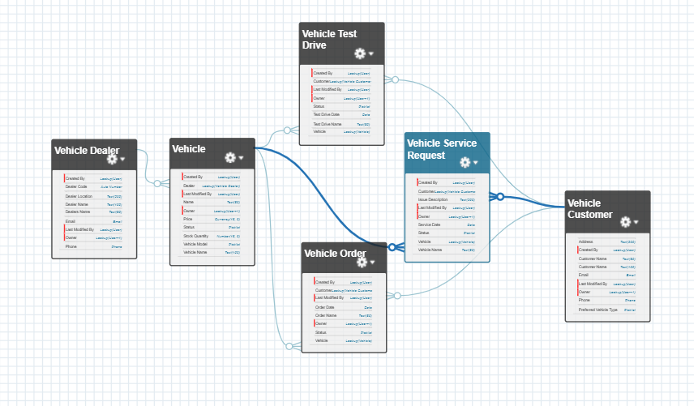

Fig 4.1 Salesforce Data Model and Object Relationships

Security Model
The security model of the WhatNext Vision Motors CRM is designed to control access to Salesforce data and functionality according to the requirements of the automobile business. Since the CRM contains information related to customers, vehicles, dealers, vehicle orders, test drives, and service requests, appropriate access control is required to protect business information and maintain data integrity.
Salesforce provides multiple levels of security for controlling access to CRM data, including object-level permissions, field-level security, user permissions, and record-level access. These security mechanisms help determine which objects and fields users can access and which records they can view or modify. A layered security approach helps ensure that users receive the access required to perform their business responsibilities while protecting sensitive CRM information.
For the implemented WhatNext Vision Motors CRM, Organization-Wide Default (OWD) sharing settings are used to define the default record-level access for the major custom objects. The configured objects include Vehicle, Vehicle Customer, Vehicle Dealer, Vehicle Order, Vehicle Service Request, and Vehicle Test Drive. The OWD settings provide Public Read/Write access for internal users, while external access is set to Private, helping restrict external access to the CRM records by default.

The security configuration supports the operational requirements of the CRM while helping maintain data confidentiality, integrity, and controlled access. By defining appropriate record-level access, the system allows authorized users to perform their assigned business activities efficiently while reducing the risk of unauthorized access to business information.
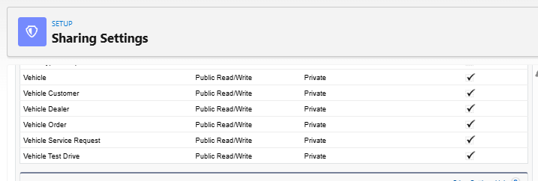

Fig 4.2 Organization-Wide Default Sharing Settings for CRM Objects

5. SALESFORCE DEVELOPMENT – BACKEND & CONFIGURATIONS
5.1 Setup Environment & DevOps Workflow
The WhatNext Vision Motors CRM was developed and configured using a Salesforce Developer Edition environment. Salesforce Setup and Object Manager provided the primary environment for creating and configuring the components required for the CRM application.
The development environment was used to manage the Salesforce configuration, including custom objects, fields, relationships, page layouts, automation, security settings, and other platform components. The development process involved configuring the required components, testing their functionality, identifying configuration issues, and validating the implemented features.
The Salesforce environment provided a centralized platform for developing and testing the CRM according to the defined business requirements. Individual features were configured and tested before being considered part of the overall CRM solution.
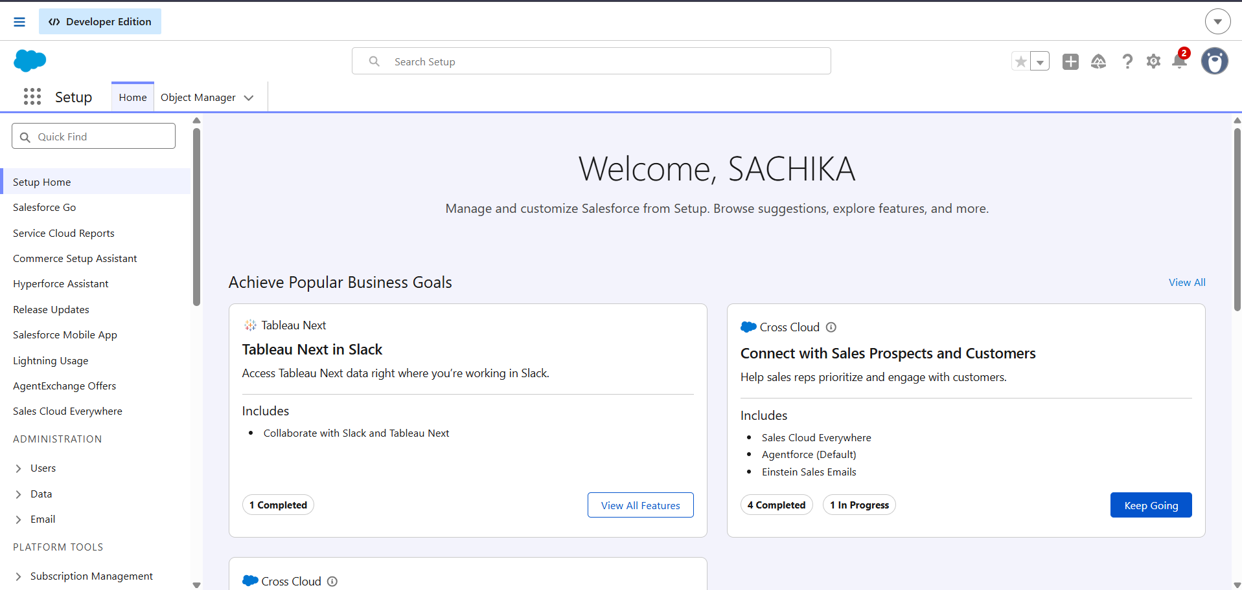

Fig 5.1 Salesforce Developer Edition Setup Environment

5.2 Customization of Objects and Fields.
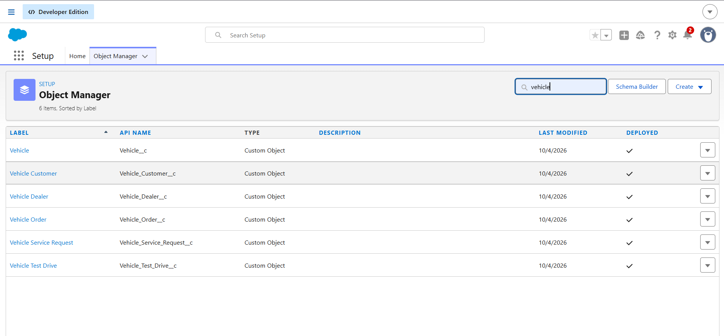
The Object Manager in Salesforce was used to create and manage the custom objects required for the WhatNext Vision Motors CRM. The implemented CRM contains six custom objects: Vehicle, Vehicle Customer, Vehicle Dealer, Vehicle Order, Vehicle Service Request, and Vehicle Test Drive. These objects represent the major entities involved in customer management, vehicle inventory, dealer management, order processing, test-drive management, and service request management.
Fig 5.2 Custom Objects Configured in Salesforce Object Manager

Vehicle Customer Object and Fields
The Vehicle Customer object is used to maintain and manage customer information within the WhatNext Vision Motors CRM. It contains fields required to identify customers, communicate with them, and capture their vehicle preferences. The configured fields include Customer Name, Address, Email, Phone, and Preferred Vehicle Type, along with the standard Salesforce ownership and record-management fields.
The Preferred Vehicle Type field is configured as a picklist, while fields such as Email, Phone, and Address use appropriate Salesforce data types for storing customer information. These fields provide the basic information required for customer management and are also used by other CRM processes involving customers.

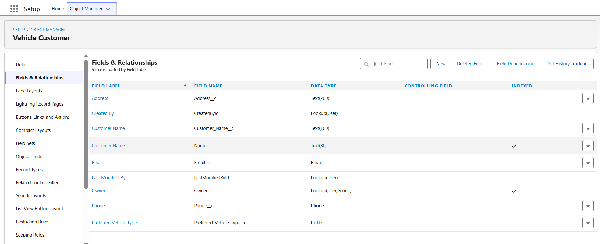

Fig 5.3 Vehicle Customer Object Fields and Relationships

Vehicle Object and Fields
The Vehicle object is used to maintain and manage vehicle information within the WhatNext Vision Motors CRM. It stores the details required for vehicle identification, pricing, availability, inventory tracking, and dealer association. The configured fields include Vehicle Name, Vehicle Model, Price, Status, Stock Quantity, and Dealer.
The Dealer field is configured as a lookup relationship with the Vehicle Dealer object, allowing each vehicle record to be associated with a dealer. The Status and Vehicle Model fields are configured as picklists, while Price uses a currency field and Stock Quantity uses a number field. These fields support vehicle inventory management and provide the information required for vehicle-order processing.
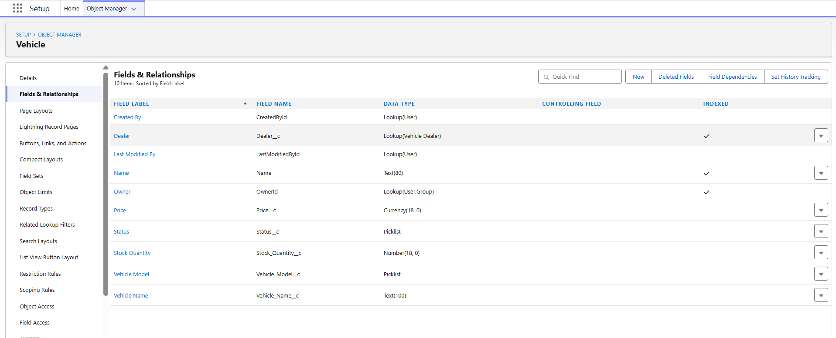

Fig 5.4 Vehicle Object Fields and Relationships

Vehicle Dealer Object and Fields
The Vehicle Dealer object is used to maintain dealer information within the WhatNext Vision Motors CRM. It stores the details required to identify dealers, maintain their locations, and support communication with them. The configured fields include Dealer Code, Dealer Location, Dealer Name, Email, and Phone.
The Dealer Code field is configured as an Auto Number, providing a unique identifier for dealer records. Dealer Location and Dealer Name use text fields, while Email and Phone use their respective Salesforce data types. These fields provide the information required for dealer management and support the dealer assignment process within the CRM.

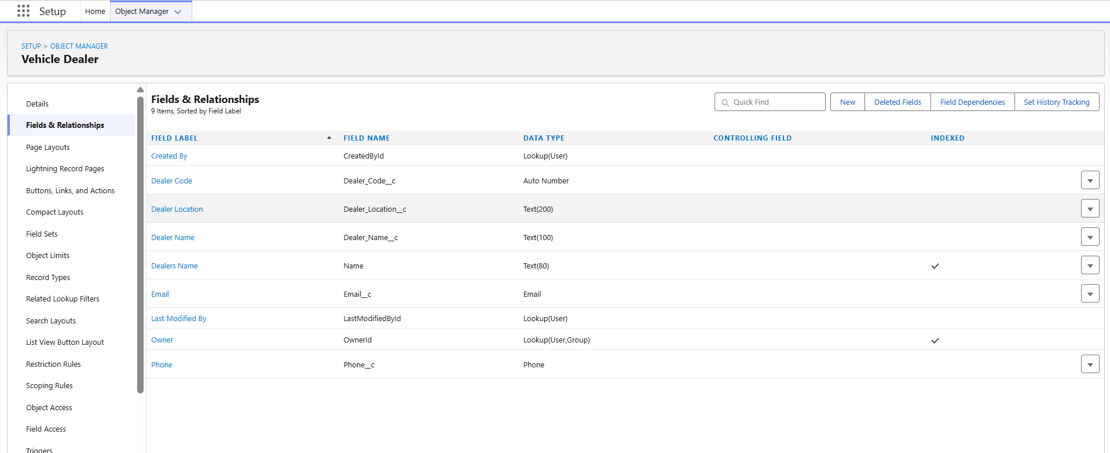

Fig 5.5 Vehicle Dealer Object Fields and Relationships
Vehicle Order Object and Fields
The Vehicle Order object is used to create and manage vehicle orders within the WhatNext Vision Motors CRM. It stores the information required to associate an order with a customer and a vehicle, record the order date, and track the current order status.
The Customer field is configured as a lookup relationship with the Vehicle Customer object, while the Vehicle field is configured as a lookup relationship with the Vehicle object. The Order Date field uses the Date data type, and the Status field is configured as a Picklist. These fields establish the connections required for vehicle order processing and support inventory-related automation.

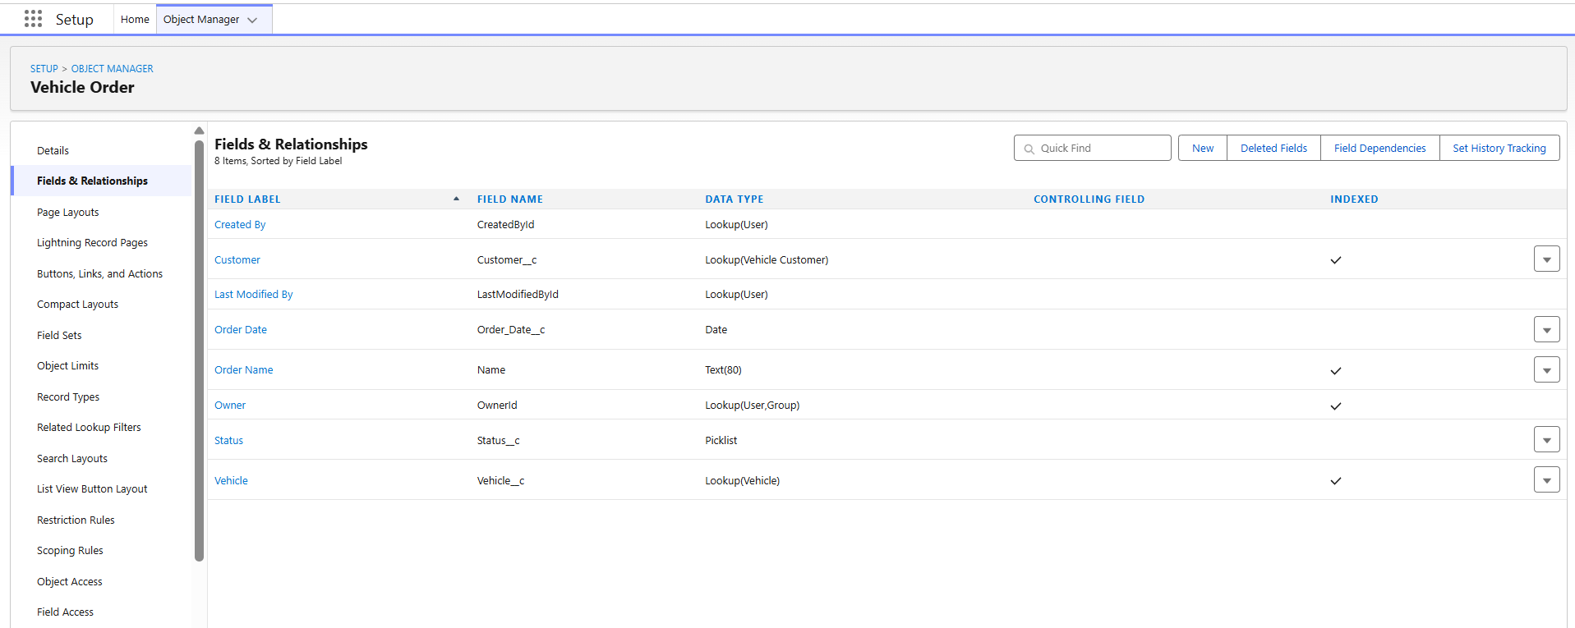

Fig 5.6 Vehicle Order Object Fields and Relationships

Vehicle Test Drive Object and Fields
The Vehicle Test Drive object is used to manage and track scheduled test drives within the WhatNext Vision Motors CRM. It stores the information required to associate a test drive with a customer and a vehicle, while also recording the scheduled date and current status of the test drive.
The Customer field is configured as a lookup relationship with the Vehicle Customer object, and the Vehicle field is configured as a lookup relationship with the Vehicle object. The Test Drive Date field uses the Date data type, while the Status field is configured as a Picklist. These fields support test-drive scheduling and provide the information required for the automated reminder process.

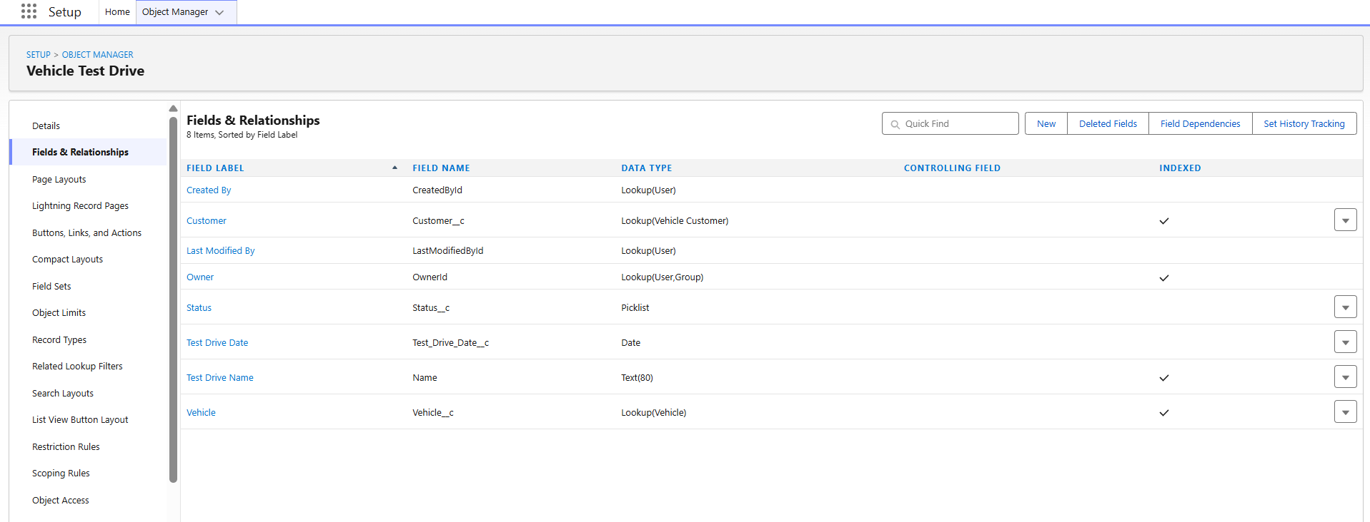

Fig 5.7 Vehicle Test Drive Object Fields and Relationships

Vehicle Service Request Object and Fields
The Vehicle Service Request object is used to manage customer service-related requests within the WhatNext Vision Motors CRM. It stores information about the customer, vehicle, service date, current request status, and the issue reported by the customer.
The Customer field is configured as a lookup relationship with the Vehicle Customer object, while the Vehicle field is configured as a lookup relationship with the Vehicle object. The Service Date field uses the Date data type, Status is configured as a Picklist, and Issue Description uses a Text field to capture the service-related issue. These fields support the organization and management of vehicle service requests.

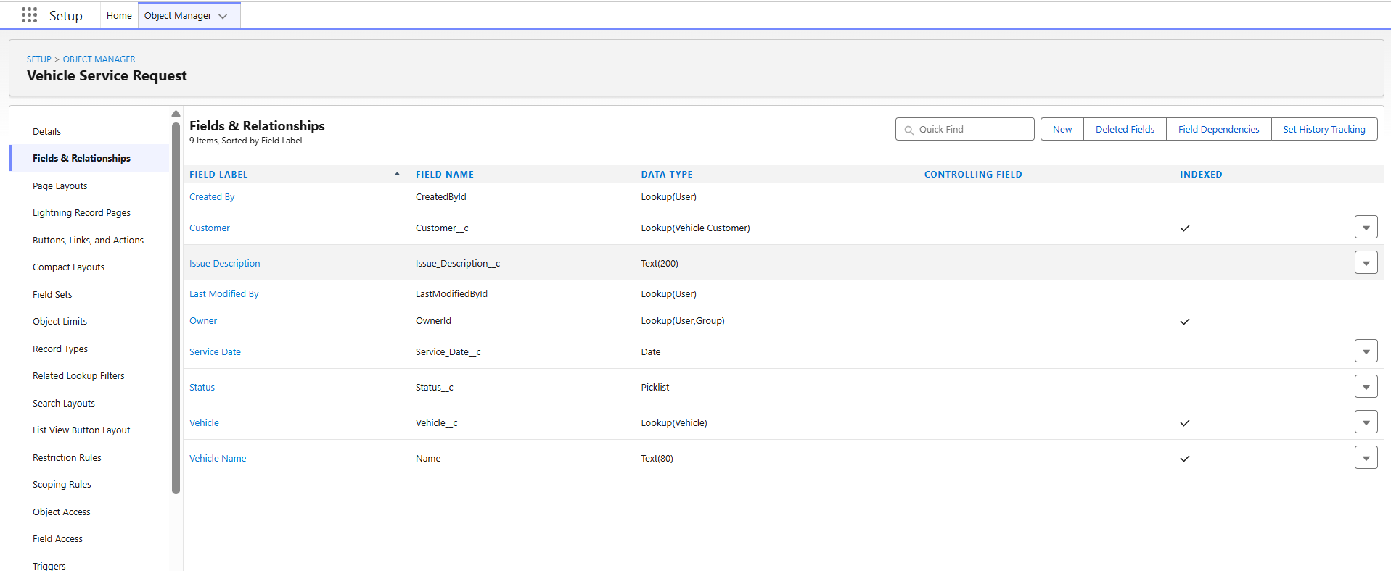

Fig 5.8 Vehicle Service Request Object Fields and Relationships
5.3 Validation Rules
No custom validation rules were implemented in the WhatNext Vision Motors CRM. The project primarily uses Salesforce Flows and Apex-based business logic to perform the required process automation and data-related checks. Therefore, no custom validation-rule configuration is included in this implementation.

5.4 Automation Using Flows
Salesforce Flows were used in the WhatNext Vision Motors CRM to automate important business processes and reduce manual effort. The implemented automation supports dealer assignment and customer communication related to scheduled test drives. Two record-triggered Flows were developed as part of the CRM implementation:
- Auto Assign Dealer
- Test Drive Remainder
These Flows use Salesforce automation capabilities to retrieve related records, evaluate business conditions, and perform the required actions automatically.

Auto Assign Dealer
The Auto Assign Dealer Flow retrieves the customer information, identifies a dealer whose location matches the customer's address, and retrieves the matching dealer record for the configured assignment process. This reduces manual dealer selection and supports efficient vehicle-order processing.

Test Drive Remainder
The Test Drive Reminder Flow was developed to automate customer notifications for scheduled vehicle test drives. The record-triggered Flow retrieves the customer information associated with the test-drive record and uses a scheduled path to process the reminder before the scheduled test-drive date. The Flow then sends the test-drive reminder to the customer's email address. (Refer Fig 5.9)

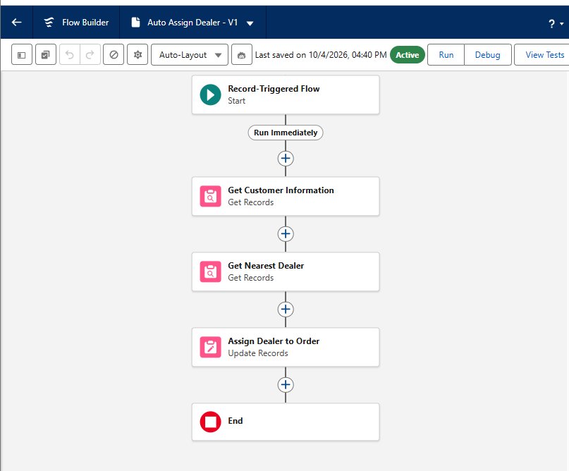
Fig 5.9 Auto Assign Dealer Record-Triggered Flow
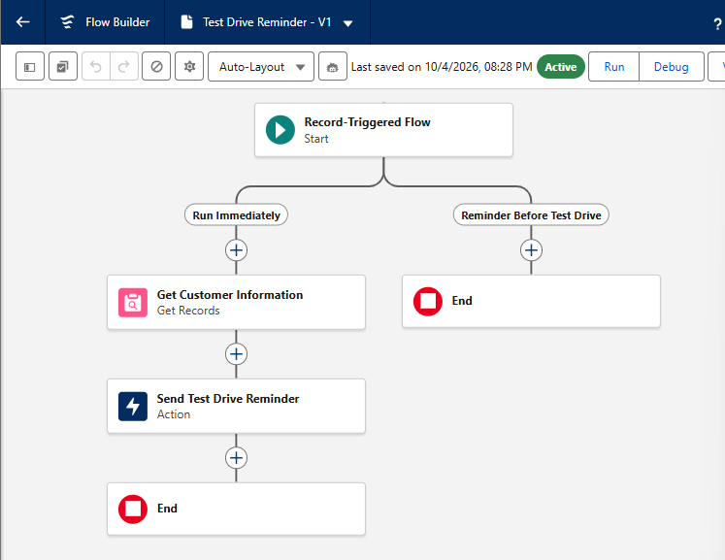

Fig 5.10 Test Drive Remainder Record-Triggered Flow
5.5 Apex Classes and Triggers
Apex was used in the WhatNext Vision Motors CRM to implement programmatic business logic that supports vehicle-order processing and inventory management. An Apex trigger and a corresponding handler class were developed to perform stock validation and update vehicle inventory based on vehicle-order status.
The trigger delegates the business logic to the handler class, providing a structured approach for managing the processing associated with vehicle-order records.

Vehicle Order Trigger Handler
The VehicleOrderTriggerHandler Apex class centralizes the business logic for vehicle orders in the WhatNext Vision Motors CRM. It handles both before and after trigger operations.
During before insert and before update, the preventOrderIfOutOfStock() method checks vehicle stock and prevents an order when the available quantity is zero or less. During after insert and after update, the updateStockOnOrderPlacement() method identifies confirmed orders and reduces the corresponding vehicle stock by one when stock is available.
The handler separates business logic from the trigger definition and supports order validation and automatic inventory updates.

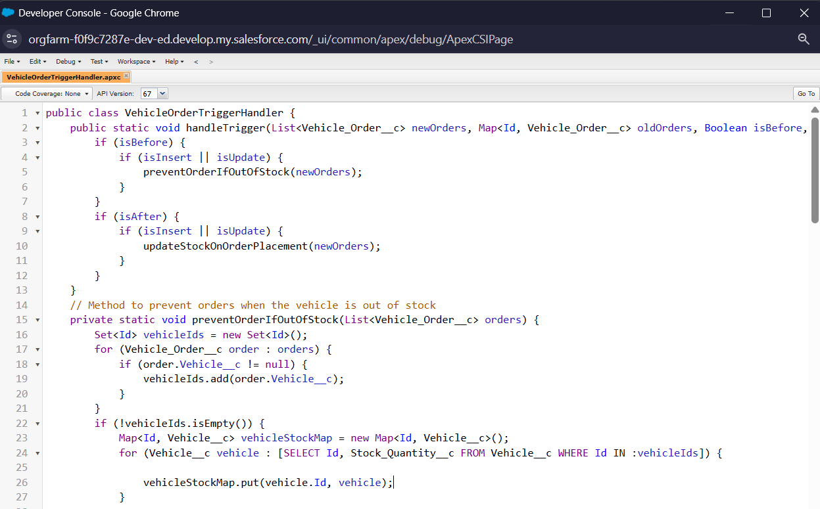

Fig 5.11 VehicleOrderTriggerHandler Apex Class
Vehicle Order Trigger
The VehicleOrderTrigger is associated with the Vehicle_Order__c object and executes during before-insert, before-update, after-insert, and after-update events. The trigger delegates the processing logic to the VehicleOrderTriggerHandler Apex class, allowing validation and inventory-related business logic to be handled separately from the trigger definition.

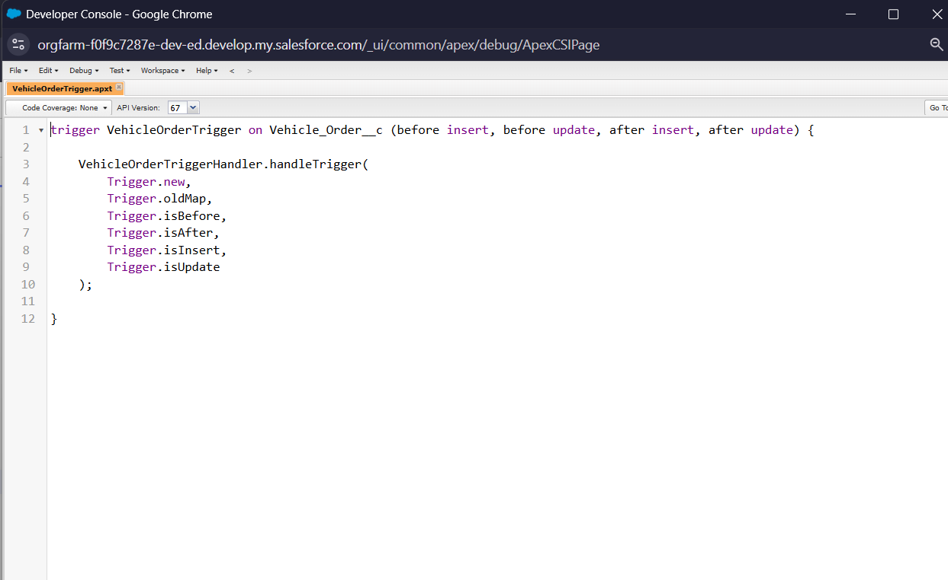

Fig 5.12 Vehicle Order Trigger

5.6 Asynchronous Apex Classes
The WhatNext Vision Motors CRM uses Batch Apex and Scheduled Apex to process pending vehicle orders and automate inventory updates. Batch Apex is used to handle multiple pending vehicle orders efficiently, while Scheduled Apex enables the batch process to be executed automatically at a scheduled time.
VehicleOrderBatch
The WhatNext Vision Motors CRM uses Batch Apex to process pending vehicle orders and update vehicle inventory automatically. The VehicleOrderBatch class implements the Database.Batchable<sObject> interface, allowing pending orders to be processed as a batch rather than individually.
The start() method retrieves vehicle orders whose status is Pending. It selects the order ID, order status, and associated vehicle so that eligible orders can be processed.
The execute() method processes the retrieved orders and identifies the vehicles associated with them. It checks the available stock quantity for each vehicle. When stock is available, the order status is changed from Pending to Confirmed, and the vehicle's stock quantity is reduced by one. The updated orders and vehicle records are then saved to Salesforce.
The finish() method executes after the batch processing is completed and records a debug message indicating that the vehicle-order batch job has finished. This Batch Apex implementation helps automate pending-order processing and maintain accurate inventory levels.

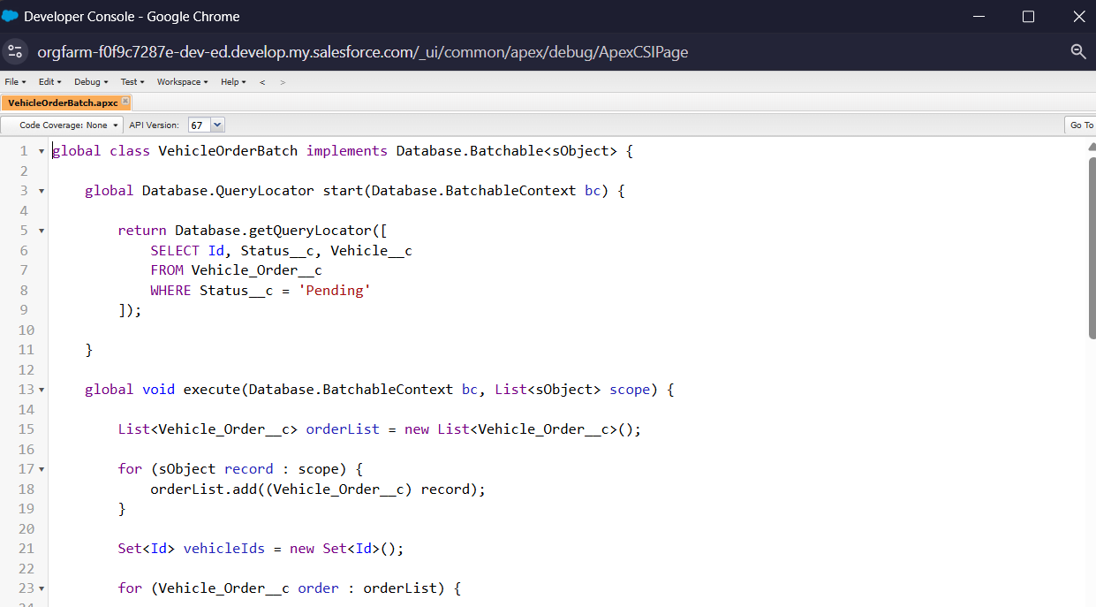

Fig 5.13 VehicleOrderBatch Apex Class

VehicleOrderBatchScheduler
The VehicleOrderBatchScheduler class was developed using Scheduled Apex to automate the execution of the VehicleOrderBatch process. The scheduler creates an instance of the batch class and uses Database.executeBatch() to start the batch job with a batch size of 50 records.
This scheduled execution reduces manual intervention in processing pending vehicle orders and supports regular order processing and inventory updates. The scheduler works together with the Batch Apex class to provide automated processing within the CRM.
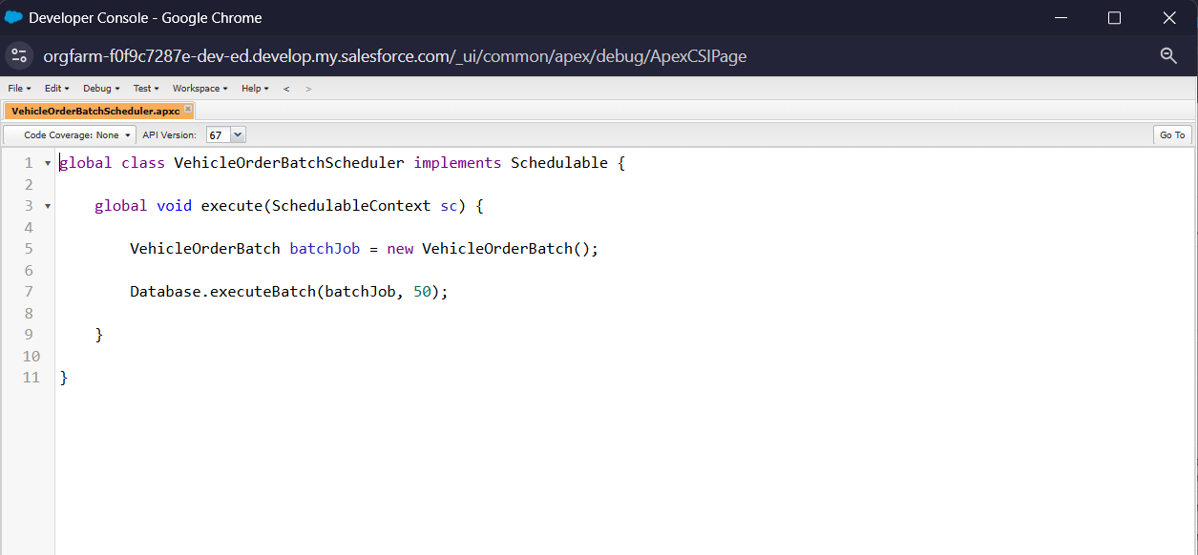

Fig 5. 14 VehicleOrderBatchScheduler Scheduled Apex Class

6. UI/UX DEVELOPMENT & CUSTOMIZATION
6.1 Lightning App via App Manager
The WhatNext Vision Motors Lightning application was configured using Salesforce Lightning Experience App Manager. The application provides a centralized workspace for accessing the CRM features developed for vehicle customers, vehicles, dealers, vehicle orders, test drives, and service requests.
The Lightning app brings the major CRM components together within a unified Salesforce environment, making it easier for users to access and manage the information required for automobile business operations. The app was configured as a Lightning application and made available in Lightning Experience.

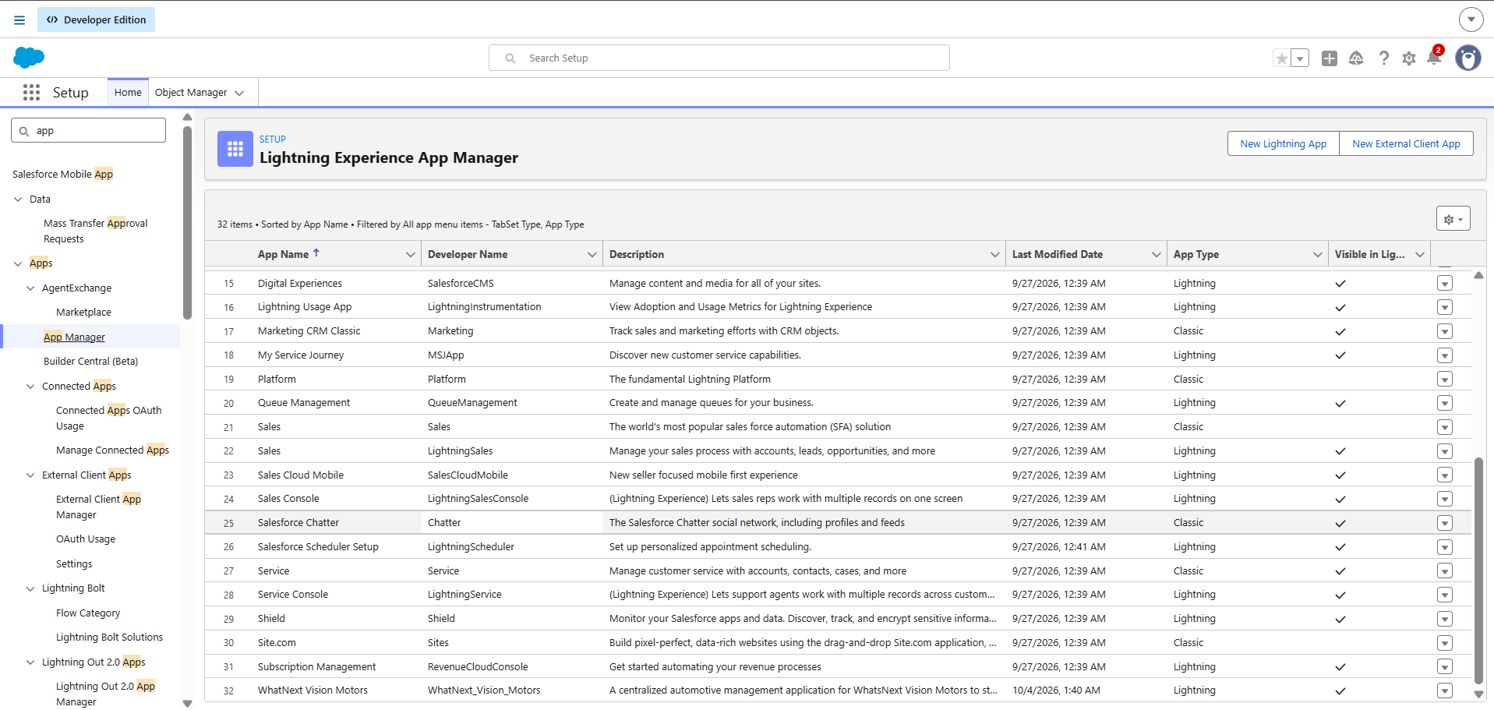

Fig 6.1 WhatNext Vision Motors Lightning App in App Manager

6.2 User Management
User Management in Salesforce is used to create and manage users who access the WhatNext Vision Motors CRM. It helps control access to Salesforce features and business data according to user responsibilities.
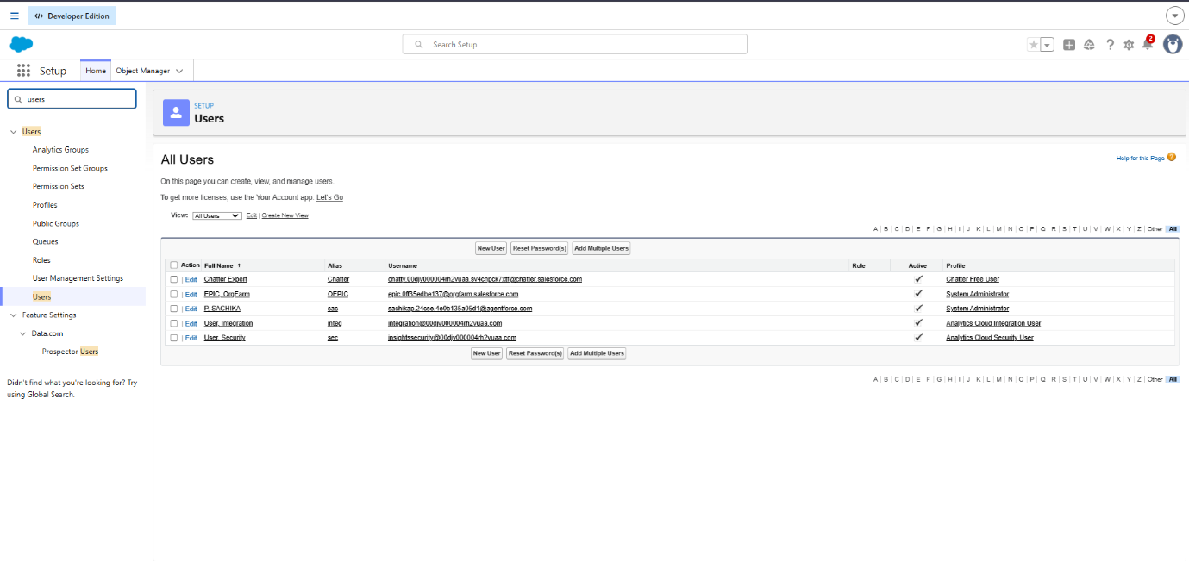
The Users page provides information such as user name, username, role, active status, and profile. Profiles and roles help manage the level of access provided to users and support controlled access to the CRM application.
Fig 6.2 Salesforce User Management

6.3 Reports and Dashboards
Salesforce Reports and Dashboards were used in the WhatNext Vision Motors CRM to organize business information and provide a clear view of important vehicle-related data. Reports present Salesforce records in a structured format, while dashboards provide a visual representation of the information for easier monitoring and analysis.
Reports and dashboards also improve the accessibility of business information by presenting relevant data in a simple and organized manner. They reduce the need to manually review individual records and help users identify important inventory details quickly. This supports efficient monitoring of vehicle availability, stock levels, and other operational information within the Salesforce CRM.
The Vehicle Inventory Report provides a consolidated view of vehicle inventory in the CRM. It displays the vehicle name, model, availability status, stock quantity, price, and dealer information. The report also summarizes the total number of records and available stock quantity, helping users monitor vehicle inventory efficiently.

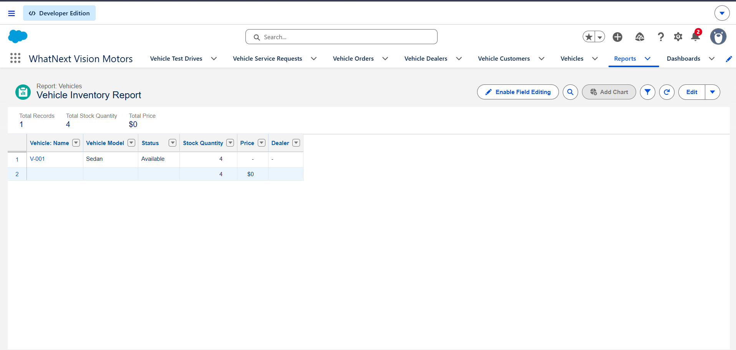

Fig 6.3 Vehicle Inventory Report

A Vehicle Inventory Dashboard was created using the report to provide a visual representation of inventory information. The dashboard helps users quickly understand vehicle availability and stock-related information, supporting faster monitoring and business decision-making.

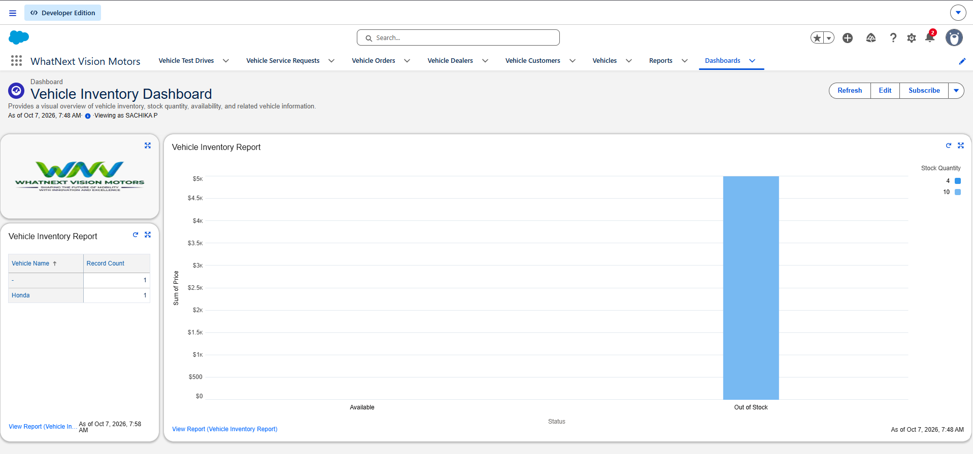

Fig 6.4 Vehicle Inventory Dashboard

7. DATA LOADING PROCESS
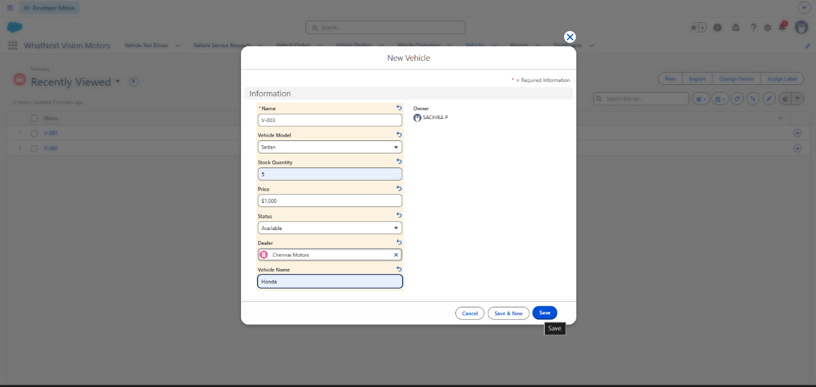
The project data was loaded into the WhatNext Vision Motors CRM by manually creating records through Salesforce record-entry forms. Required information was entered for Vehicle Customer, Vehicle, Vehicle Dealer, Vehicle Order, Vehicle Test Drive, and Vehicle Service Request objects.
Fig 7.1 Data Loading in Salesforce
7.1 Testing of Salesforce Flows
The implemented Salesforce Flows were tested using actual records in the WhatNext Vision Motors CRM to verify their functionality.
The Auto Assign Dealer Flow was tested by creating a vehicle order and verifying the configured dealer-assignment process. The Flow retrieves the customer information, identifies a dealer whose location matches the customer’s address, and retrieves the matching dealer record for assignment. This verifies the automated dealer selection based on the customer’s location.
The Test Drive Reminder Flow was tested using a scheduled test-drive record, and the reminder email was successfully received by the customer before the scheduled test-drive date. These tests confirmed that both Flows performed their intended automation successfully.

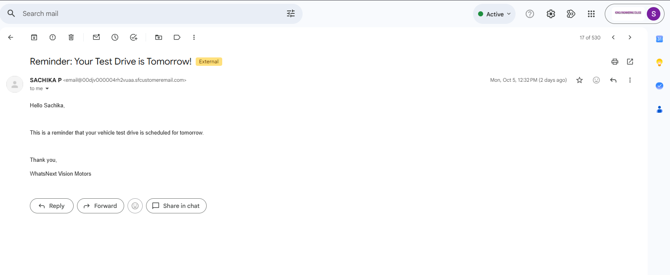
Fig 7.2 Test Drive Remainder Email Output

7.2 Testing of Apex Trigger and Handler
The VehicleOrderTrigger and VehicleOrderTriggerHandler were tested to verify vehicle-order validation and inventory-related processing. The trigger was configured for before-insert, before-update, after-insert, and after-update events, while the handler performs stock validation and updates vehicle stock for confirmed orders. Testing was performed using vehicle-order records and corresponding vehicle inventory data to verify the implemented business logic.

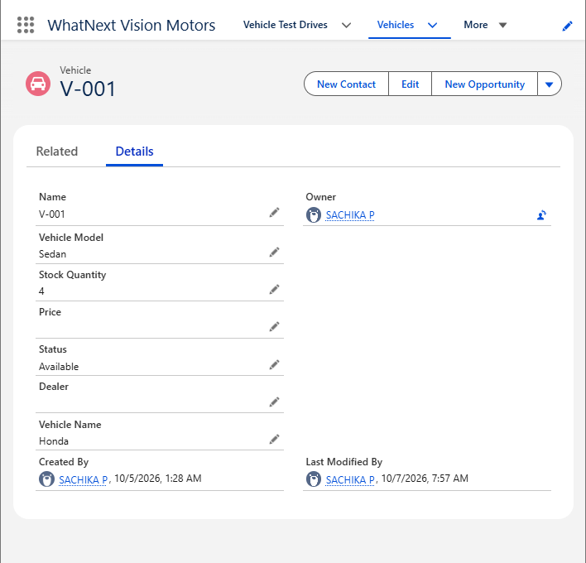
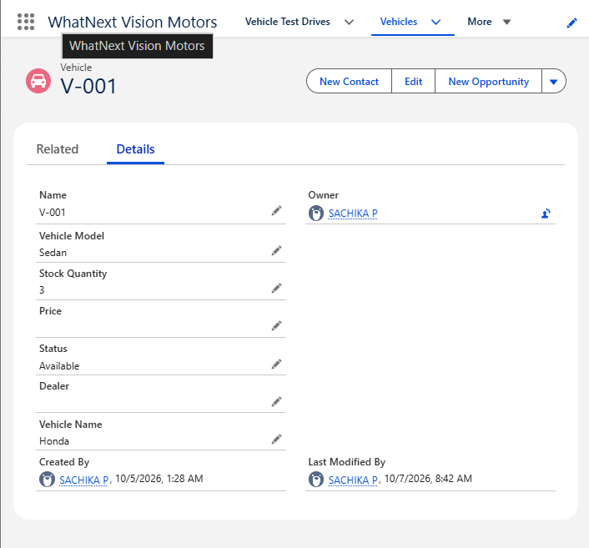
This vehicle currently has 4 units available in stock.

After the confirmed vehicle order was created, the Apex Trigger invoked the VehicleOrderTriggerHandler, which reduced the available vehicle stock by one.

Fig 7.3 Vehicle Stock Before and After Apex Trigger Execution
7.3 Testing of Batch Apex and Scheduled Apex
The VehicleOrderBatch class was tested by processing pending vehicle orders and verifying that eligible orders were changed to Confirmed when stock was available. The corresponding vehicle stock quantity was reduced by one after successful processing. The Batch Apex job was completed successfully with no failures, and the Scheduled Apex class was configured to execute the batch process automatically.

Fig 7.4 Vehicle Order Batch Apex Execution and Test Result
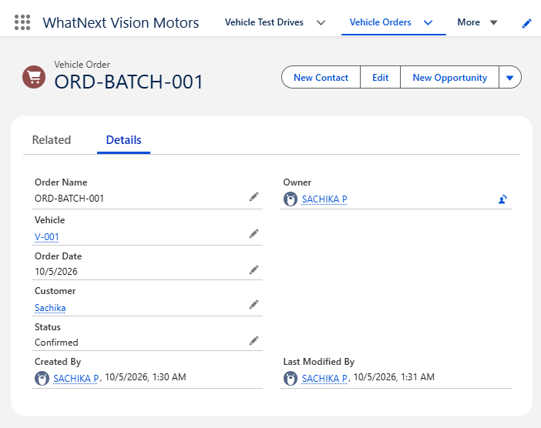

8. DEPLOYMENT ,DOCUMENTATION & MAINTENANCE
8.1 Deployment Strategy
The WhatNext Vision Motors CRM was developed and tested in a Salesforce Developer Edition environment. The configured Salesforce components, including custom objects, fields, Flows, Apex classes, triggers, Batch Apex, Scheduled Apex, reports, dashboards, and security configurations were tested before being considered ready for deployment. The deployment approach focuses on validating each component and its dependencies to ensure that the CRM functionality remains consistent when moved to the required Salesforce environment.

8.2 Project Documentation
The project documentation was prepared to provide a structured overview of the WhatNext Vision Motors CRM and its implementation. It covers the business requirements, data model, security model, Salesforce configurations, automation, Apex development, testing, reports, dashboards, and maintenance considerations. Screenshots of important Salesforce configurations and functional outputs are included to provide evidence of the implemented features.

8.3 Maintenance and Monitoring
The WhatNext Vision Motors CRM can be maintained by regularly monitoring Salesforce automation, Apex jobs, scheduled processes, data records, reports, and dashboards. Any errors or unexpected behavior can be identified through Salesforce monitoring tools such as Debug Logs, Apex Jobs, and Scheduled Jobs. Regular review of data and automation helps maintain accurate vehicle inventory, order processing, customer communication, and overall CRM functionality.

8.4 Troubleshooting
Troubleshooting involves identifying and resolving configuration, automation, data, and Apex-related issues within the CRM. Salesforce tools such as Debug Logs, Flow Details, Apex Jobs, and Scheduled Jobs can be used to identify failures and determine their causes. Testing individual components and reviewing error messages helps ensure that the implemented CRM features continue to operate correctly.

9. CONCLUSION
The WhatNext Vision Motors Salesforce CRM successfully provides a centralized platform for managing vehicle customers, vehicles, dealers, orders, test drives, and service requests. The project integrates Salesforce configuration, automation, Apex programming, Batch Apex, Scheduled Apex, reports, dashboards, and security features to support efficient automobile business operations. The implemented Flows automate dealer-related processing and test-drive reminders, while Apex Trigger and Handler logic supports vehicle stock validation and inventory updates. Batch and Scheduled Apex provide automated processing of pending vehicle orders. The developed reports and dashboards provide a clear view of vehicle inventory and support effective monitoring and decision-making. Overall, the project demonstrates how Salesforce can be used to develop a structured and automated CRM solution that reduces manual effort, improves data management, and supports efficient customer and vehicle-related operations.

